Contents
Design Pattern Introduction 1
Creational Design Patterns: 2
Singleton Pattern 2
Factory Pattern 4
Factory Method Pattern(Pending) 8
Abstract Factory Pattern 8

Design Pattern Introduction
The design patterns are language-independent strategies for solving common object-oriented design problems. Design Patterns are best practices how to solve common know problems
Some of the benefits of using design patterns are:
- Design Patterns are already defined and provides industry standard approach to solve a recurring problem, so it saves time if we sensibly use the design pattern.
- Using design patterns promotes reusability that leads to more robust and highly maintainable code. It helps in reducing total cost of ownership (TCO) of the software product.
- Since design patterns are already defined, it makes our code easy to understand and debug. It leads to faster development and new members of team understand it easily.

Java Design Patterns are divided into three categories
S.N. | Pattern & Description
1 | Creational Patterns  These design patterns provides way to create objects while hiding the creation logic, rather than instantiating objects directly using new operator. This gives program more flexibility in deciding which objects need to be created for a given use case.
2 | Structural Patterns  These design patterns concern class and object composition. Concept of inheritance is used to compose interfaces and define ways to compose objects to obtain new functionalities.
3 | Behavioral Patterns  These design patterns are specifically concerned with communication between objects.

Creational Design Patterns:

Singleton Pattern
Ensure that only one instance of a class is created and Provide a global access point to the object.
Motivation
The singleton pattern is one of the simplest design patterns: it involves only one class which is responsible to instantiate itself, to make sure it creates not more than one instance; in the same time it provides a global point of access to that instance. In this case the same instance can be used from everywhere, being impossible to invoke directly the constructor each time.
Intent
- Ensure that only one instance of a class is created.
- Provide a global point of access to the object.

Implementation
The implementation involves a static member in the "Singleton" class, a private constructor and a static public method that returns a reference to the static member.
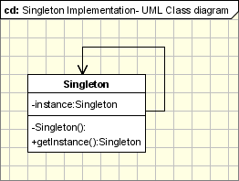
The Singleton Pattern defines a getInstance operation which exposes the unique instance which is accessed by the clients. getInstance() is is responsible for creating its class unique instance in case it is not created yet and to return that instance.

Lazy instantiation
class Singleton
{
private static Singleton instance; //Static Members

//make the constructor private so that this class cannot be //instantiated
private Singleton()
{
...
}
public static synchronized Singleton getInstance()
{
if (instance == null)
instance = new Singleton();
return instance;
}
...
public void doSomething()
{
...
}
}

The standard implementation shown in the above code is a thread safe implementation, but it's not the best thread-safe implementation beacuse synchronization is very expensive when we are talking about the performance. We can see that the synchronized method getInstance does not need to be checked for syncronization after the object is initialized. If we see that the singleton object is already created we just have to return it without using any syncronized block. This optimization consist in checking in an unsynchronized block if the object is null and if not to check again and create it in an syncronized block. This is called double locking mechanism.

Early instantiation using implementation with static field.

In the following implementation the singleton object is instantiated when the class is loaded and not when it is first used, due to the fact that the instance member is declared static. This is why in we don't need to synchronize any portion of the code in this case. The class is loaded once this guarantee the uniquity of the object.
class Singleton
{
private static Singleton instance = new Singleton();
//make the constructor private so that this class cannot be //instantiated
private Singleton()
{
System.out.println("Singleton(): Initializing Instance");
}
public static Singleton getInstance()
{
return instance;
}
public void doSomething()
{
System.out.println("doSomething(): Singleton does something!");
}
}

You can notice in the above code that getInstance method ensures that only one instance of the class is created. The constructor should not be accessible from the outside of the class to ensure the only way of instantiating the class would be only through the getInstance method.

The getInstance method is used also to provide a global point of access to the object and it can be used in the following manner:
Singleton.getInstance().doSomething();

Example 1 - Logger Classes
The Singleton pattern is used in the design of logger classes. This class is usually implemented as singletons, and provides a global logging access point in all the application components without being necessary to create an object each time a logging operation is performed.
Example 2 - Configuration Classes
The Singleton pattern is used to design the classes which provide the configuration settings for an application. By implementing configuration classes as Singleton not only that we provide a global access point, but we also keep the instance we use as a cache object. When the class is instantiated (or when a value is read) the singleton will keep the values in its internal structure. If the values are read from the database or from files this avoids the reloading the values each time the configuration parameters are used.

Hot Spot:
- Multithreading - A special care should be taken when singleton has to be used in a multithreading application.
- Serialization - When Singletons are implementing Serializable interface they have to implement readResolve method in order to avoid having 2 different objects.
- Classloaders - If the Singleton class is loaded by 2 different class loaders we'll have 2 different classes, one for each class loader.
- Global Access Point represented by the class name - The singleton instance is obtained using the class name. At the first view this is an easy way to access it, but it is not very flexible. If we need to replace the Sigleton class, all the references in the code should be changed accordingly.

Factory Pattern
Creates objects without exposing the instantiation logic to the client and Refers to the newly created object through a common interface.
Motivation
The Factory Design Pattern is probably the most used design pattern in modern programming languages like Java and C#.
Intent
- Creates objects without exposing the instantiation logic to the client.
- refers to the newly created object through a common interface
Implementation

Case1: Case 2:
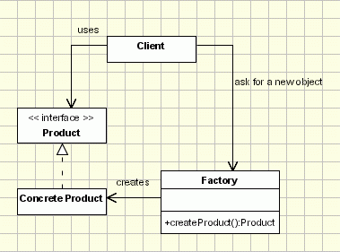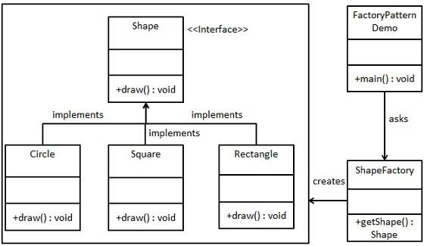
Case1:
The implementation is really simple
- The client needs a product, but instead of creating it directly using the new operator, it asks the factory object for a new product, providing the information about the type of object it needs.
- The factory instantiates a new concrete product and then returns to the client the newly created product (casted to abstract product class).
- The client uses the products as abstract products without being aware about their concrete implementation.
Case 2:
We're going to create a Shape interface and concrete classes implementing the Shape interface. A factory class ShapeFactory is defined as a next step.
FactoryPatternDemo, our demo class will use ShapeFactory to get a Shape object. It will pass information (CIRCLE / RECTANGLE / SQUARE) to ShapeFactory to get the type of object it needs.
Step 1
Create an interface.
Shape.java
public interface Shape {
void draw();
}

Step 2
Create concrete classes implementing the same interface.
Rectangle.java
public class Rectangle implements Shape {

@Override
public void draw() {
System.out.println("Inside Rectangle::draw() method.");
}
}
Square.java
public class Square implements Shape {

@Override
public void draw() {
System.out.println("Inside Square::draw() method.");
}
}
Circle.java
public class Circle implements Shape {

@Override
public void draw() {
System.out.println("Inside Circle::draw() method.");
}
}

Step 3
Create a Factory to generate object of concrete class based on given information.
ShapeFactory.java
public class ShapeFactory {

//use getShape method to get object of type shape
public Shape getShape(String shapeType){
if(shapeType == null){
return null;
}
if(shapeType.equalsIgnoreCase("CIRCLE")){
return new Circle();
} else if(shapeType.equalsIgnoreCase("RECTANGLE")){
return new Rectangle();
} else if(shapeType.equalsIgnoreCase("SQUARE")){
return new Square();
}
return null;
}
}
Step 4
Use the Factory to get object of concrete class by passing information such as type.
FactoryPatternDemo.java
public class FactoryPatternDemo {

public static void main(String[] args) {
ShapeFactory shapeFactory = new ShapeFactory();

//get an object of Circle and call its draw method.
Shape shape1 = shapeFactory.getShape("CIRCLE");

//call draw method of Circle
shape1.draw();

//get an object of Rectangle and call its draw method.
Shape shape2 = shapeFactory.getShape("RECTANGLE");

//call draw method of Rectangle
shape2.draw();

//get an object of Square and call its draw method.
Shape shape3 = shapeFactory.getShape("SQUARE");

//call draw method of circle
shape3.draw();
}
}

Step 5
Verify the output.
Inside Circle::draw() method.
Inside Rectangle::draw() method.
Inside Square::draw() method.

Factory Method Pattern(Pending)

Defines an interface for creating objects, but let subclasses to decide which class to instantiate and Refers to the newly created object through a common interface.

Abstract Factory Pattern
Provides one level of interface higher than the factory pattern. It is used to return one of several factories.

Intent
Abstract Factory offers the interface for creating a family of related objects, without explicitly specifying their classes.

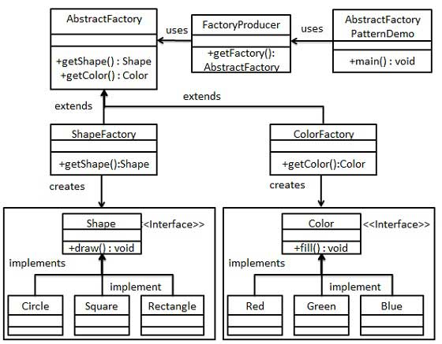

Step 1
Create an interface for Shapes.
Shape.java
public interface Shape {
void draw();
}
Step 2
Create concrete classes implementing the same interface.
Rectangle.java
public class Rectangle implements Shape {

@Override
public void draw() {
System.out.println("Inside Rectangle::draw() method.");
}
}
Square.java
public class Square implements Shape {

@Override
public void draw() {
System.out.println("Inside Square::draw() method.");
}
}
Circle.java
public class Circle implements Shape {

@Override
public void draw() {
System.out.println("Inside Circle::draw() method.");
}
}
Step 3
Create an interface for Colors.
Color.java
public interface Color {
void fill();
}
Step4
Create concrete classes implementing the same interface.
Red.java
public class Red implements Color {

@Override
public void fill() {
System.out.println("Inside Red::fill() method.");
}
}
Green.java
public class Green implements Color {

@Override
public void fill() {
System.out.println("Inside Green::fill() method.");
}
}
Blue.java
public class Blue implements Color {

@Override
public void fill() {
System.out.println("Inside Blue::fill() method.");
}
}
Step 5
Create an Abstract class to get factories for Color and Shape Objects.
AbstractFactory.java
public abstract class AbstractFactory {
abstract Color getColor(String color);
abstract Shape getShape(String shape) ;
}
Step 6
Create Factory classes extending AbstractFactory to generate object of concrete class based on given information.
ShapeFactory.java
public class ShapeFactory extends AbstractFactory {

@Override
public Shape getShape(String shapeType){
if(shapeType == null){
return null;
}
if(shapeType.equalsIgnoreCase("CIRCLE")){
return new Circle();
} else if(shapeType.equalsIgnoreCase("RECTANGLE")){
return new Rectangle();
} else if(shapeType.equalsIgnoreCase("SQUARE")){
return new Square();
}
return null;
}

@Override
Color getColor(String color) {
return null;
}
}
ColorFactory.java
public class ColorFactory extends AbstractFactory {

@Override
public Shape getShape(String shapeType){
return null;
}

@Override
Color getColor(String color) {
if(color == null){
return null;
}
if(color.equalsIgnoreCase("RED")){
return new Red();
} else if(color.equalsIgnoreCase("GREEN")){
return new Green();
} else if(color.equalsIgnoreCase("BLUE")){
return new Blue();
}
return null;
}
}
Step 7
Create a Factory generator/producer class to get factories by passing an information such as Shape or Color
FactoryProducer.java
public class FactoryProducer {
public static AbstractFactory getFactory(String choice){
if(choice.equalsIgnoreCase("SHAPE")){
return new ShapeFactory();
} else if(choice.equalsIgnoreCase("COLOR")){
return new ColorFactory();
}
return null;
}
}
Step 8
Use the FactoryProducer to get AbstractFactory in order to get factories of concrete classes by passing an information such as type.
AbstractFactoryPatternDemo.java
public class AbstractFactoryPatternDemo {
public static void main(String[] args) {

//get shape factory
AbstractFactory shapeFactory = FactoryProducer.getFactory("SHAPE");

//get an object of Shape Circle
Shape shape1 = shapeFactory.getShape("CIRCLE");

//call draw method of Shape Circle
shape1.draw();

//get an object of Shape Rectangle
Shape shape2 = shapeFactory.getShape("RECTANGLE");

//call draw method of Shape Rectangle
shape2.draw();

//get an object of Shape Square
Shape shape3 = shapeFactory.getShape("SQUARE");

//call draw method of Shape Square
shape3.draw();

//get color factory
AbstractFactory colorFactory = FactoryProducer.getFactory("COLOR");

//get an object of Color Red
Color color1 = colorFactory.getColor("RED");

//call fill method of Red
color1.fill();

//get an object of Color Green
Color color2 = colorFactory.getColor("Green");

//call fill method of Green
color2.fill();

//get an object of Color Blue
Color color3 = colorFactory.getColor("BLUE");

//call fill method of Color Blue
color3.fill();
}
}
Step 9
Verify the output.
Inside Circle::draw() method.
Inside Rectangle::draw() method.
Inside Square::draw() method.
Inside Red::fill() method.
Inside Green::fill() method.
Inside Blue::fill() method.

Hot Spot:
We should use the Abstract Factory design pattern when:
- the system needs to be independent from the way the products it works with are created.
- the system is or should be configured to work with multiple families of products.
- a family of products is designed to work only all together.
- the creation of a library of products is needed, for which is relevant only the interface, not the implementation, too.
- abstractFactory class declares only an interface for creating the products. The actual creation is the task of the ConcreteProduct classes, where a good approach is applying the Factory Method design pattern for each product of the family.
- Extending factories can be done by using one Create method for all products and attaching information about the type of product needed.

